**Group I**

**Bus Ticket Reservation System**

**Business Requirements Document m**

**V1.0.0**



|  |  |  |  |
| --- | --- | --- | --- |
|  | **Prepared By / Last Updated By** | **Reviewed by** | **Approved By** |
| **Name** | Group I  1.Avinash Singh  2.Deepak LNU  3.Neha Singh  4.N.L. Sahithi  5.Tanima Chatterjee |  |  |
| **Role** | Programmer Analyst Trainee |  |  |
| **Signature** |  |  |  |
| **Date** | 01-12-2018 |  |  |

**Table of Contents**

**1.** **Introduction** **3**

**1.1** **Purpose of this document** **3**

**1.2** **Project Overview 3**

**1.3** **Scope 3**

**1.4** **Intended Audience 3**

**1.5** **Constraints, Assumptions and Dependencies 4**

**1.6** **Definition & Acronyms 4**

**2.** **Process Architecture** **5**

**3.** **Use Case Diagram** **7**

**4.** **Sequence Diagram** **8**

**4.1** **User Book Ticket** **8**

**4.2** **User Cancel Ticket** **8**

**4.2** **Admin** **9**

**5.** **System Diagram** **10**

**6.** **System Requirements** **11**

**6.1** **Functional Requirements** **11**

6.1.1 Bus Ticket Reservation System-Customer Registration **11**

6.1.2 Bus Ticket Reservation System-Login Page **12**

6.1.3 Bus Ticket Reservation System-Signup Page **13**

6.1.4 Bus Ticket Reservation System-Customer Registration **14**

6.1.5 Bus Ticket Reservation System-Cancellation Page **16**

6.1.6 Update Profile **18**

6.1.7 Manage Master Data **20**

**7.** **Business Profile Analysis** **23**

**7.1** **Current Scenario** **23**

7.1.1 ‘As-is’ Process Flow **23**

7.1.2 Process Flow Detail **24**

7.1.3 Proposed Solution **24**

7.1.4 ‘To-be’ Process **24**

**8.** **Process Definitions Data Flow Diagram** **22**

**9.** **ER Diagram** **23**

**10.** **Business Rules** **24**

**11.** **Demo Screens** **25**

**12.** **References** **34**

1. **INTRODUCTION**
   1. **Purpose of the Document**

The purpose of the Business Requirements Document is to systematically capture requirements for the project and the system **Bus Ticket Reservation System (BTR)**. Bus Ticket Reservation system is used for managing the activities like Booking ticket, scheduling travel, Cancelling ticket and Route Searching. The customer can have a stress-free ticket booking experience without any hectic waiting in the queue, facilitating real time booking.

* 1. **PROJECT OVERVIEW**

Our System provides the transportation facility to the customers based on their requirement. We provide two type of buses like A/C and Non-A/C. The charges are different for different buses which depends on the distance, the customer wants to travel. This System maintains all the records of the online bus reservation which is only accessed by the Admin. Until now the tickets were issued in the buses only and was difficult to track the details of the bookings.

* 1. **SCOPE**

The scope of the system is explained through its modules as follows

* Customer Registration - The system will generate the customer id and store the details in the system.
* Book Ticket - By administrators to book the tickets for the customer into the system
* Cancel Ticket - By administrators to cancel the tickets for the customer into the system
* View history and update profile – By administrators to view history and update the customer information like name, address, contact no etc.
* Manage Master Data - By administrators to manage master data like Bus information, route information, bus schedules etc. The administrator should have the data to be updated into the system.
  1. **Intended Audience**
* Developers, Testers, Mentor and Manager.
* All associates related to the project.
* End User Client.
  1. **Constraints, Assumptions and Dependencies**

**Assumptions**:

* The BTR Admin must possess transaction data along with their application.
* The user details given are valid.
* The user has a minimum required balance for transaction in his account.

**System Constraints:**

* If there is any failure in identification process, the user cannot proceed further with the booking.
* The user should have the required balance to complete the transaction.
* The source and destination should be valid.

**Design Constraints:**

* Only administrator can modify the master data.
* Transaction can be accomplished only after logging in.

1. **PROCESS ARCHITECTURE**

#### **Physical Architecture**:

A physical architecture is an arrangement of physical elements, (system elements and physical interfaces) that provides the designed solution for a product, service, or enterprise. It is intended to satisfy logical architecture elements and system requirements. Auto Identification Process follows a three layered architecture namely presentation layer, business logic layer and data access layer.

* **Presentation Tier** is the tier in which the users interact with an application. Presentation Tier Contents Shared UI code, Code Behind and Designers used to represent information to user.
* **Business Tier** is mainly working as the bridge between Data Tier and Presentation Tier. All the Data passes through the Business Tier before passing to the presentation Tier. Business Tier is the sum of Business Logic Layer, Data Access Layer and Value Object and other components used to add business logic.
* **Data Tier** is basically the server which stores all the application’s data. Data tier contents Database Tables, XML Files and other means of storing Application Data.

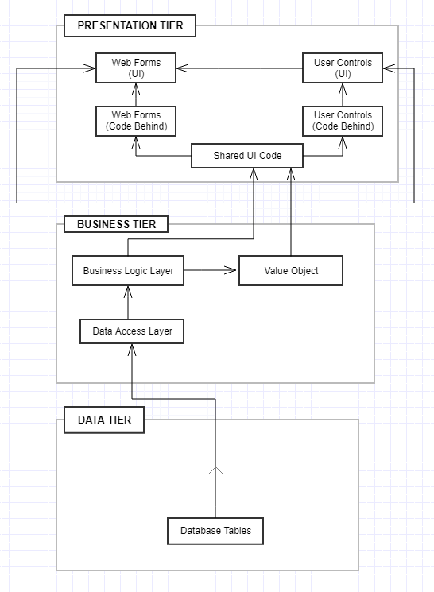

**Figure:2.1 Physical Architecture**

#### **Logical Architecture:**

The Logical Architecture defines the Processes (the activities and functions) that are required to provide the required [User Services](http://www.iteris.com/itsarch/html/user/userserv.htm). Many different [Processes](http://www.iteris.com/itsarch/html/pspec/pspecs.htm) must work together and share information to provide a User Service. The Processes can be implemented via software, hardware, or firmware. The Logical Architecture is independent of technologies and implementations

**3-Layered Architecture Logical Diagram:**

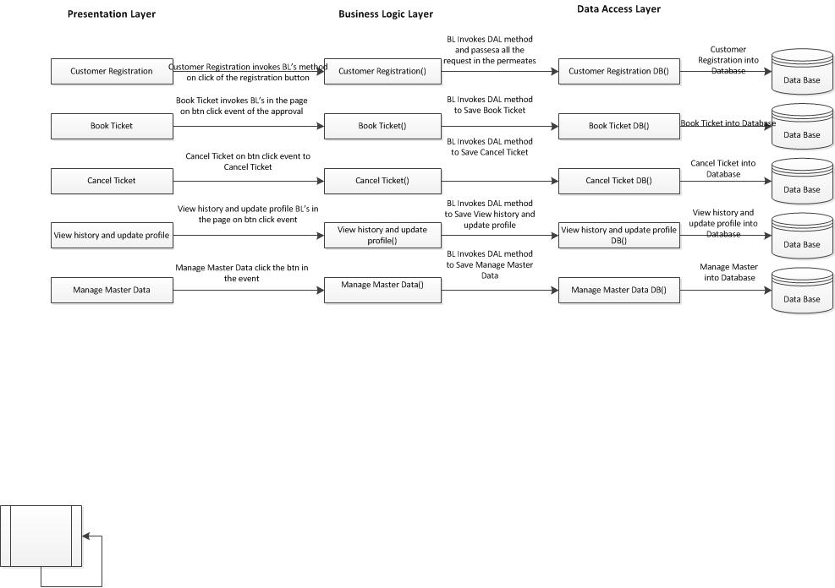

**Figure:2.1 Logical Architecture**

**3. Use Case Diagram**

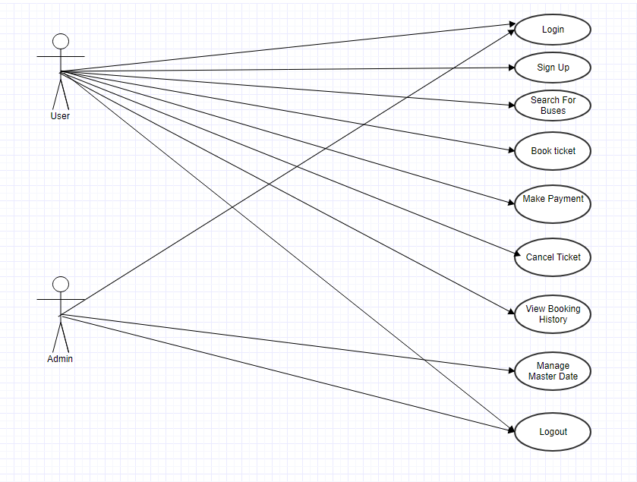

**Figure:3.1 Use Case Diagram**

**4. Sequence Diagram**

**4.1.** **User Book Ticket**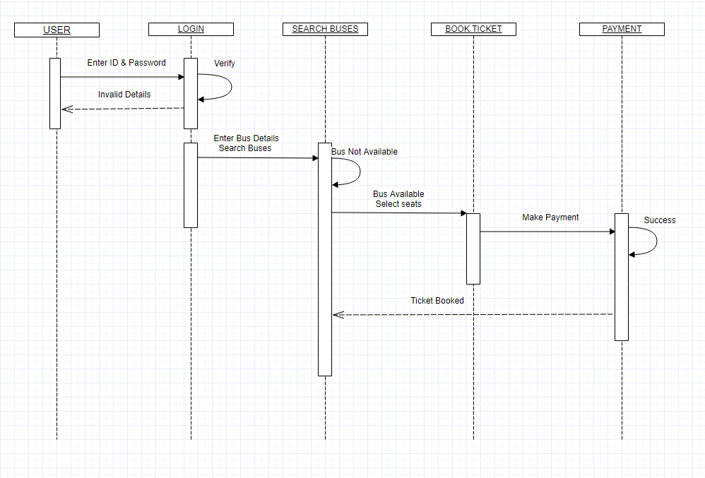

**Figure:4.1 Sequence Diagram-User Book ticket**

**4.2.** **User- Cancel Ticket**

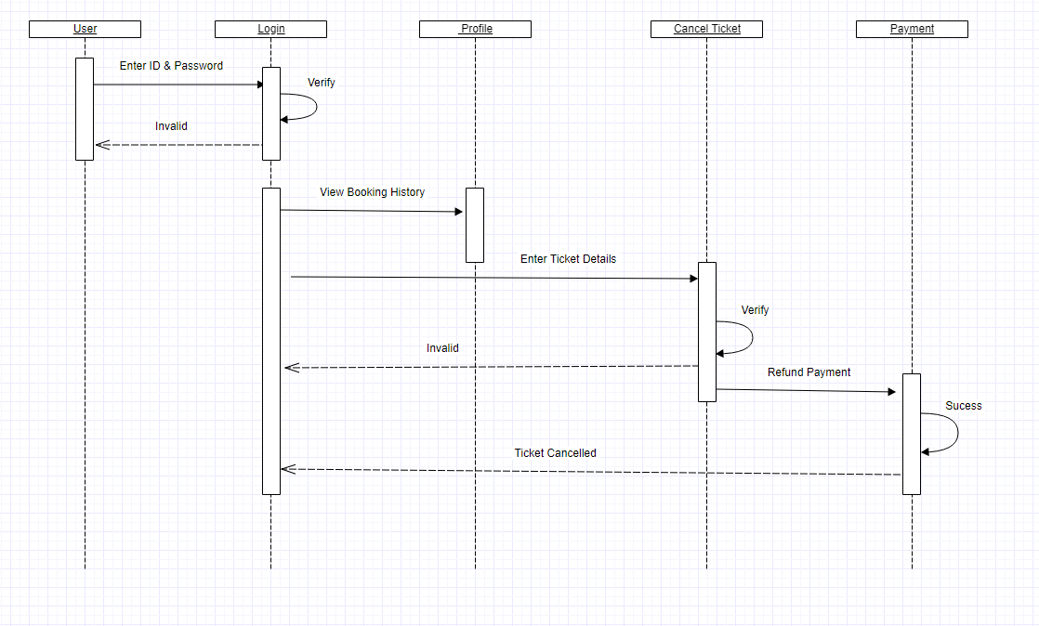

**Figure:4.2 Sequence Diagram-User Cancel ticket**

**4.3.**  **Admin**

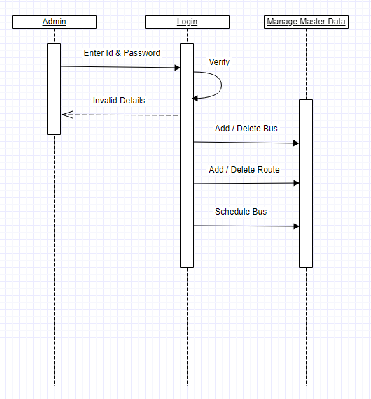

**Figure:4.3 Sequence Diagram-Admin**

**5.** **System Diagram**

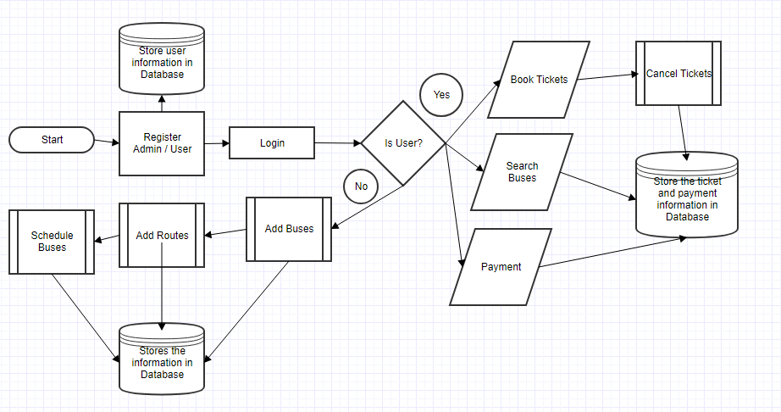

**Figure:5.1 System Diagram**

**6. System Requirements**

**6.1. Functional Requirements:**

### **6.1.1**. **Bus Ticket Reservation System – Home Page**

When the user visits the website, Home page appear where the user should be able to

* Login
* Search for buses as per his requirements.
* Know more about website

Under home page, we need below Interface Requirements.

**User Interface Screen:**

From – The destination location to be selected from drop down list

To - The source location to be selected from drop down list

Journey Date – The valid date of journey should be filled by the user

Search - Button to search buses by submitting inputs.

**Pre-Conditions:**

The User needs to enter all the details of the journey to search for available buses.

**Post Conditions:**

The system should show the list of available buses as per user’s requirement.

**Failed End Condition:**

The system should throw an error message if any of the validations is wrong. The error message and error code need to be identified during design. The validation and business rules are mentioned in the business rules section.

**Steps & Actions:**

* System should display all the necessary details
* The source and destination should be selected from dropdown list
* All the required fields should be filled
* User should select valid journey from the calendar.
* On clicking Search button, To and From locations should be checked from database along with date of journey and result should be displayed in new page.

**Business Rules & Validations:**

* All details are mandatory
* The date of journey should be should be on current date or before 2 Days.
* The source and destination should be different

**6.1.2.** **Bus Ticket Reservation System – Login Page**

When the user clicks on Login on the Home Page, Login page should appear where a registered user can log in to his/her account using his/her username and password or a new user can create a new account.

Under Login page, we need below Interface Requirements.

**User Interface Screen:**

Username – Registered mail id of the user to be entered in this field.

Password - User’s password to be entered in this field.

Login – Button to submit login credentials.

Sign Up – Button for new user registration.

Cancel – Button to cancel log in and return to homepage.

**Pre-Conditions:**

The User needs to enter his credentials to access his account.

**Post Conditions:**

The system should show user’s account or search results after he/she is successfully logged in.

**Failed End Condition:**

The system should throw an error message if one of the validations is wrong. The error message and error code need to be identified during design. The validation and business rules are mentioned in the business rules section.

**Steps & Actions:**

* System should display all the necessary details
* The username and password should be entered by the user
* All the required fields should be filled
* On clicking Login button, the login credentials should be matched from database.
* On clicking Sign Up button, a new user registration page should open.

**Business Rules & Validations:**

* All details are mandatory
* Every user should have unique username

**6.1.3. Bus Ticket Reservation System – Sign up Page**

When the user clicks on Sign Up button on the Login Page, Sign Up page should appear. Register user form should have basic attributes/fields as mentioned in UI Interface Screen section.

At any given point of time, the user can Deselect/Reset all or can go to home page by the clicking home. Under Sign Up page, we need below Interface Requirements.

**User Interface Screen:**

Name - The Customer name should be filled by the user

Email Address - The Email Address should be filled by the user

Date of Birth - Enter the input to represents the customer DOB in DD/MM/YYYY format

Customer password - The password should be filled by user

Confirm password - The Confirm password should be filled by user

**Pre-Conditions:**

The User need to enter all the details of the customer to be registered into the system.

**Post Conditions:**

The system should find weightage of the customer, generate the customer id and stored along with the customer details.

**Failed End Condition:**

The system should throw an error message if one of the validations is wrong. The error message and error code need to be identified during design. The validation and business rules are mentioned in the business rules section.

**Steps & Actions:**

* System should display all the necessary details.
* Get all the necessary information.
* On register or Update the system needs to calculate the weightage based on the customer type
* Store the details into the system

**Business Rules & Validations:**

* The name should contain only alphabets and space.
* Contact no should be 10 digits.
* Email id should be in a valid format ([*abc@xyz.com*](mailto:abc@xyz.com)*).*
* All details are mandatory.
* At the time of registration, the following task needs to be done:

**6.1.4. Bus Ticket Reservation System – Search Bus Page**

**Search Bus:**

By clicking on search bus the user can search for available buses by giving from city, to city and date of journey. The result is a dynamic list showing details of bus with departure date and journey time.

**UI Interface Screen:**

**Check Buses:**

From Location - From Location need to be Inserted

To Location - To Location need to be inserted

Journey Date - The Journey Date should be filled by the user

**Search Results:**

From Location - From Location need to be Inserted

To Location - To Location need to be inserted

Bus Name - Represents the Bus name

Bus Number- Bus Registration Number

Departure Time - Represents the departure time of Bus

Journey Time - The total journey time of from city and to city.

**Pre-Conditions:**

The user should have the details of the journey to search for bus in the system.

**Post Conditions:**

The user should have the details of the journey to search for bus in the system.

**Success End Condition:**

On success it should show list of available buses.

**Failed End Condition:**

The system should throw an error message if one of the validations is wrong. The error message and error code needs to be identified during design. The validation and business rules are mentioned in the business rules section.

**Steps & Actions:**

* System should display all the necessary details.
* Get all the necessary information like from location, to location, Date of Journey, Number of tickets.
* From Location and to location must be selected.
* On the check availability it should check the availability and display all the available Bus based on the specified date and place. The Bus schedule details must be displayed on the same details.
* Select the required Bus and go for the book Ticket.
* Generate Ticket and display the ticket information.
* Identify the Bus information for book ticket
* Identify the Route Information
* Identify the Schedule Information
* Identify the Seat Availability
* Update the number of available tickets in the selected schedule.

**Business Rules & Validations:**

* From and to should not be the same.
* Date should not be less than current date.
* All the fields are Mandatory.
* At the time of Booking check the available Buses based on the Date, Type, No. of Seats and Place.
* Store the Information of Ticket in System.
* Update the number of seats available in the selected schedule.

**6.1.5. Bus Ticket Reservation System – Seat Selection Page**

**Select Seat:**

The user can book tickets by selecting seats from the seat layout as per his/her preference, the user is asked to enter the details of passengers for number of selected seats.

**User Interface Screen:**

**Select Preferred Seat:**

The user is shown seats as custom checkboxes that display seat number.

**Enter Passengers Details:**

Name- Enter name of the passenger

Age- Enter age of passengers in Textbox

Gender- Radio Button showing Male or Female

**Pre-Conditions:**

The user should select a bus as per his/her preference to select seat.

**Post Conditions:**

The user should click Book button to confirm seat selection.

The user should click add traveler details to add details of the passengers.

**Success End Condition:**

On success the seat and passenger’s details should be added successfully.

**Failed End Condition:**

The system should throw an error message if one of the validations is wrong. The error message and error code needs to be identified during design. The validation and business rules are mentioned in the business rules section.

**Steps & Actions:**

* System should display all the necessary details
* The user selects seats as per his/her preferences
* The users click book button to confirms seat selection
* The user enters details of passengers for selected no of seats
* The user clicks on add traveler to add passenger details.
* The seat information for that bus on that date is updated.
* The passenger’s details are added for ticket generation.

**Business Rules & Validations:**

* The customer should be already registered in the system.
* All the fields are Mandatory.
* Update the seat information for selected bus.

**6.1.6. Bus Ticket Reservation System – Booking Page**

**Book Ticket:**

By administrators to book the tickets for the customer into the system. The administrator should have the details from the customer to be entered into the system. The system should check the availability of the seats in the Bus & it should book and generate the ticket id and store the details in the system.

**UI Interface Screen:**

**Check Ticket:**

From Location - From Location need to be Inserted

To Location - To Location need to be inserted

Journey Date - The Journey Date should be filled by the user

**Book Ticket:**

Bus Name - Represents the Bus name

Seats Available - Represent the Available Seats

Time - Represents the Bus Time

Journey Time - The total journey time of from city and to city.

**Pre-Conditions:**

The admin should have the details of the travel to be booked into the system.

**Post Conditions:**

The admin should have the details of the travel to be booked into the system.

**Success End Condition:**

On success a message should be displayed “Ticket Booked successfully”.

**Failed End Condition:**

The system should throw an error message if one of the validations is wrong. The error message and error code needs to be identified during design. The validation and business rules are mentioned in the business rules section.

**Steps & Actions:**

* System should display all the necessary details.
* Get all the necessary information like Customer ID, from location, to location, Date of Journey, Number of tickets.
* From Location and to location must be typed/selected.
* On the check availability it should check the customer id, check the availability and display all the available Bus based on the specified date and place. The Bus schedule details must be displayed on the same details.
* Select the required Bus and go for the book Ticket.
* Generate the unique Ticket id for each and every ticket and display the ticket information.
* Identify the Bus information for book ticket
* Identify the Route Information
* Identify the Schedule Information
* Identify the Seat Availability
* Update the number of available tickets in the selected schedule.

**Business Rules & Validations:**

* The customer should be already registered in the system.
* From and to should not be the same.
* Date should not be less than current date.
* All the fields are Mandatory.
* At the time of Booking check the available Buses based on the Date, Type, No. of Seats and Place.
* Get the preferred Bus and Generate the Ticket id for the individual tickets.
* Store the Information of Ticket in System.
* Update the number of seats available in the selected schedule.

**6.1.7. Bus Ticket Reservation System – Cancellation Page**

Administrators to cancel the tickets for the customer into the system. The administrator should have the details from the customer to be entered into the system. The system should check for the ticket information for cancellation calculates the amount for the refund and store the details in the system.

**User Interface Screen:**

* Customer ID - Customer ID
* Ticket ID - Ticket ID
* Date of Journey - Enter the input to represents DD/MM/YYYY format

**Pre-Conditions / Assumptions:**

Ticket ID should be entered correctly to cancel the ticket.

**Post Conditions:**

The system should on successful cancellation the increment the number of available tickets; the cancelled ticket information should be recorded in database.

**Success End Condition:**

On success a message should be displayed “Ticket Cancelled successfully. Please pay the remaining amount (Balance amount) to the customer”.

**Failed End Condition:**

The system should throw an error message if one of the validations is wrong. The error message and error code needs to be identified during design. The validation and business rules are mentioned in the business rules section.

**Steps & Actions:**

* System should display all the necessary details.
* Get Customer ID, Ticket ID to be cancelled.
* Get the Date of Journey also as a security measure to avoid unintended tickets getting cancelled.
* On select of ***cancel ticket*** the system must calculate the amount to be refunded.
* On successful cancellation it should redirects to success message. The following message should be displayed.

Ticket Cancelled Successfully

Refund Amount = Amount Paid by the Customer – deduction amount

* Store the cancellation details into the system

Update the number of seats available in the schedule in which the customer cancelled his tickets.

**Business Rules & Validations:**

* Customer id should be existing one.
* Ticket id should be existing one.
* The customer should have booked the ticket with the entered ticket id for travelling on the entered journey date.
* All the fields are Mandatory.

At the time of Cancellation, the system needs to calculate the cancellation details, store the cancellation details into the system and update the number of seats available.

**6.1.8. Manage Master Data**

Administrators to manage master data like Bus information, route information, bus schedules etc. The administrator should have the data to be updated into the system.

**UI Interface Screen:**

**Main Details:**

* Add new Bus - Add New Bus
* Add new route -Add New Bus
* Schedule Bus -Schedule Bus

**Add new bus**:

* Bus Name -To Add Bus name
* Bus Number – To Add Registration Number of Bus
* Bus Type - To Add Bus Type
* No of seats – To Add No of Seats
* Route ID - To Enter Route Id of Bus
* Dept. Time – To Enter Departure Time of the bus
* JTime - To enter the total journey time.

**Add new route**:

* From - From City
* To -To City
* Price – Base fare for this route

**Schedule bus**:

* Edit/Delete Bus
* Edit/delete Route

**Pre-Conditions / Assumptions:**

The admin should have the data to be updated into the system.

**Post Conditions:**

The system should update the bus information, route information and schedules from the system

**Success End Condition:**

On success a message should be displayed **“Information updated successfully”.**

**Failed End Condition**

The system should throw an error message if one of the validations is wrong. The error message and error code needs to be identified during design. The validation and business rules are mentioned in the business rules section.

**Steps & Actions**

* System should display all the necessary information for to Add New Bus, Add new Route and Schedule bus.
* In the Add new bus, necessary details like Bus name, Bus type, No of Seats should be displayed.
* On adding the information, the system should generate a unique bus ID and check if the no of seats provided matches with maximum number of seats specified for that bus type and store the data into the database.
* In the Add new route, necessary details like from, to, Cost should be displayed.
* On adding the information, the system should generate a unique route ID and Store the information in the database.
* In schedule bus, necessary details for from, to, Bus Name, Time should be provided.
* On entering the information, the system should find the route id and bus id and store in the database along with time.
* The system should also ensure that no bus is scheduled on the same time.
* Identify the Bus information.
* Identify the Maximum seats by type information for buses
* Identify the Route Information.
* Identify the Schedule Information.

**Business Rules & Validations**

**a) In add new bus**

* Bus type should be existing one.
* Unique bus ID should be automatically generated.
* No of seats provided must be less than or equal to the no of seats specified for that bus type.
* All the details are Mandatory

**b) In add new route**

* Route should not be the existing one.
* Unique route Id should be generated automatically.
* All the details are Mandatory

**c) In Schedule**

* The route should be an existing one.
* Bus should be existing one.
* There should not be any bus scheduled in same time.
* All details are mandatory.

1. **BUSINESS PROCESS ANALYSIS**

**7.1. Current Scenario**

We have presented a basic overview of the whole Bus Ticket Booking System or Process be analyzed or modeled. It is designed to be an at a glance view of Customer Bus Route and Payment showing the system as a single process with its relationship to external entities of Bus scheduled, Booking and Ticket generation.

It also identifies internal data stores of Payment, Bus-Route; Customer Ticket ensures the flow of Data between the various parts of the System.

**7.1.1. ‘As-is’ Process Flow**

It can be summarized as the following:

ADMIN

* Admins can login to the System and manage all the Functionalities of Bus Ticket Booking System.
* Admin can add, edit, delete, and view the records of Bus Schedule, Ticket Counter, Customer, and Payment.
* Admin can manage all the details of Booking, Bus Route
* Admin can also search details of Booking, customer and Bus Route and can also filter its different levels of privacy.

USER

* Similarly, the user needs to Register himself/herself for any of the desired activity.
* After a successful registration he/she needs to Login into the system to perform any of the further activities.
* The activities can include Edit, Profile, Ticket Booking, Payment Selection Method, Destination Location and others.

**7.1.2. Process Flow Detail:**

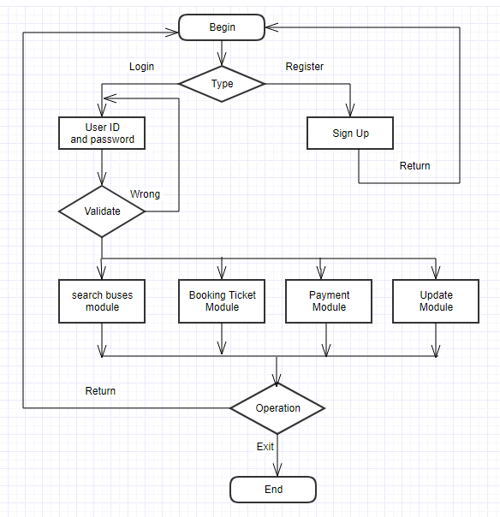

**Fig.7.1.2.: Process Flow Diagram**

**7.1.3. Proposed Solution**

* The load time for user interface shall take no longer than 2 seconds
* The log in information shall be verified and authenticated by the admin in a few seconds.
* The Queries shall return as queried by the user at the back end.
* The password may be verified according to the current Syntax as prescribed.

**7.1.4. ‘To-be’ Process**

The “To-Be” process maps with their supporting documentation can be included here

* Modes of Payment

1. **PROCESS DEFINITIONS**  
     
   **Data flow diagram**

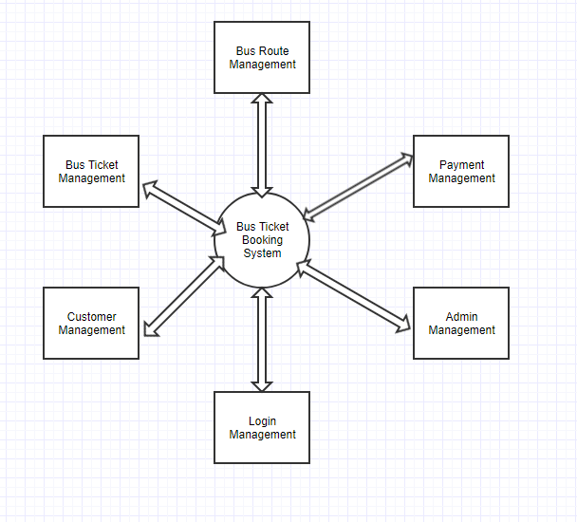

**Figure:8.1 DFD Level-0**

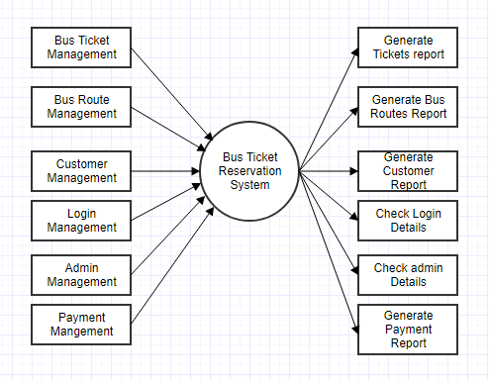

**Figure:8.1 DFD Level-1**

## 

1. **ER-Diagram**

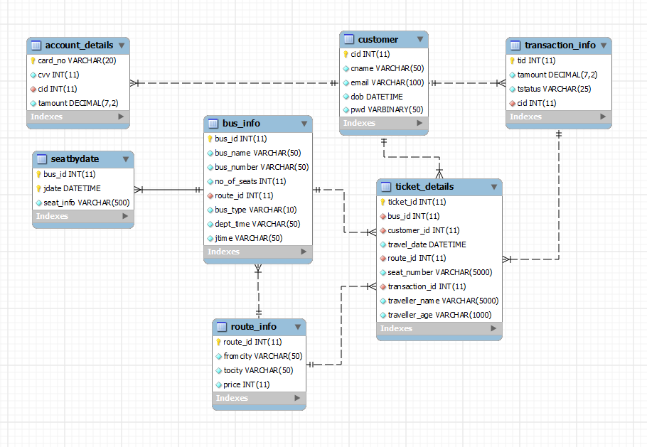

**Figure:9.1 ER-Diagram**

## **Business Rules:**

| # | Rule Name | Definition |
| --- | --- | --- |
| 1 | Booking Rule | The customer should be already registered in the system.  From and to should not be the same.  Date should not be less than current date.  All the fields are Mandatory.  At the time of Booking:  Check the available Buses based on the Date, Type, No. of Seats and Place.  Get the preferred Bus and Generate the Ticket id for the individual tickets.  Store the Information of Ticket in System. |
| 2 | Cancellation Rules | Customer id should be existing one.  Ticket id should be existing one.  The customer should have booked the ticket with the entered ticket id for travelling on the entered journey date.  All the fields are Mandatory. |
| 3 | Manage Master Data | In add new bus  Bus type should be existing one.  Unique bus ID should be automatically generated.  No of seats provided must be less than or equal to the no of seats specified for that bus type.  All the details are Mandatory  b) In add new route  Route should not be the existing one.  Unique route Id should be generated automatically.  All the details are Mandatory  c) In Schedule  The route should be an existing one.  Bus should be existing one.  There should not be any bus scheduled in same time.  All details are mandatory. |

# **HIGH LEVEL BUSINESS REQUIREMENTS**

Following are the high level requirements of the online bus ticket reservation system:

* Managing all the Bus Schedule
* Managing all the Booking
* Managing all the Ticket Counter
* Managing all the Ticket
* Managing all the Customer
* Managing all the Bus Schedule
* Managing all the Bus Route
* Managing all the Payment

1. **Demo-Screens**

**Home-Page:**

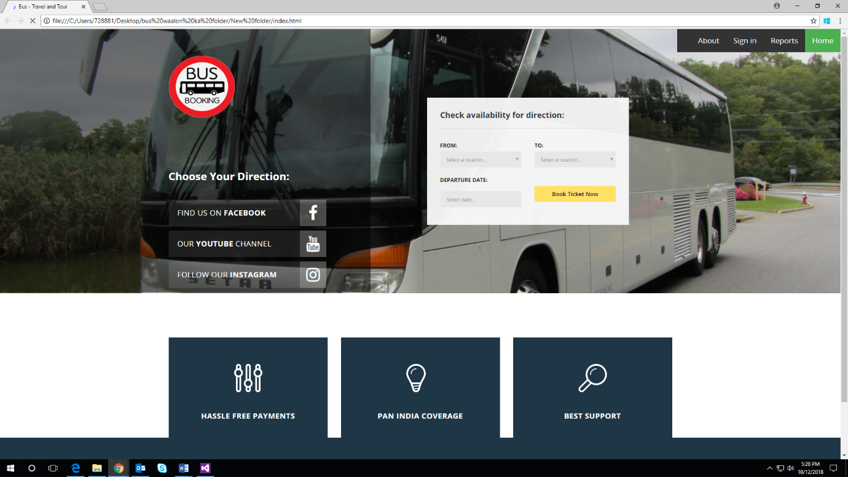

**Signup-Page:**

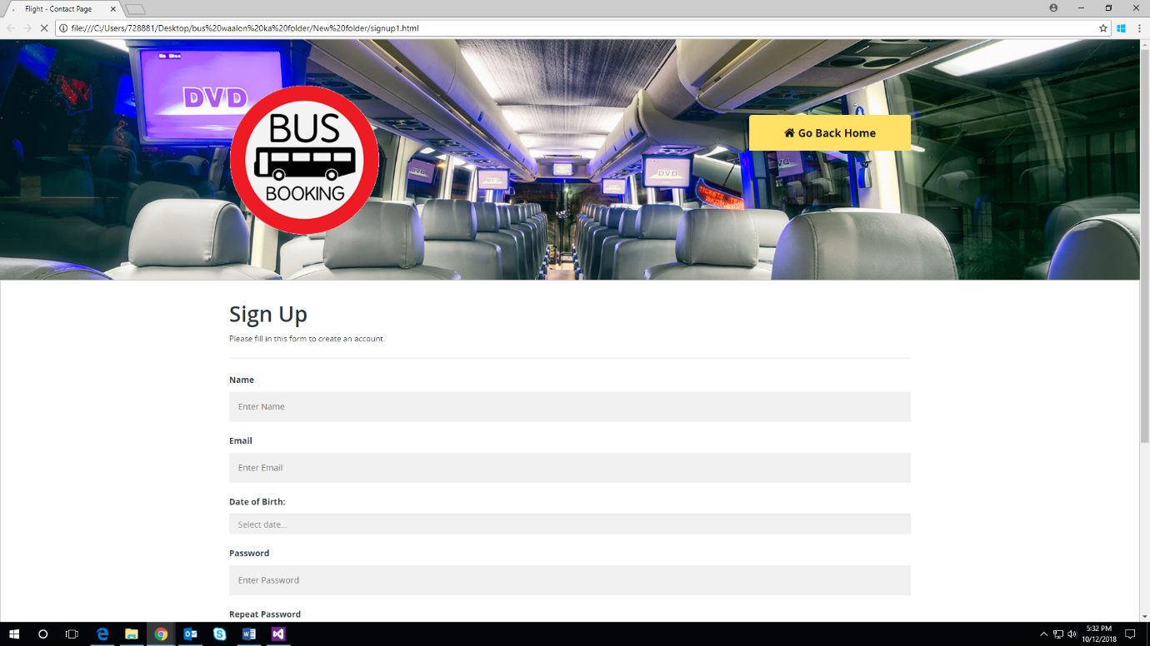

**Login-Page:**

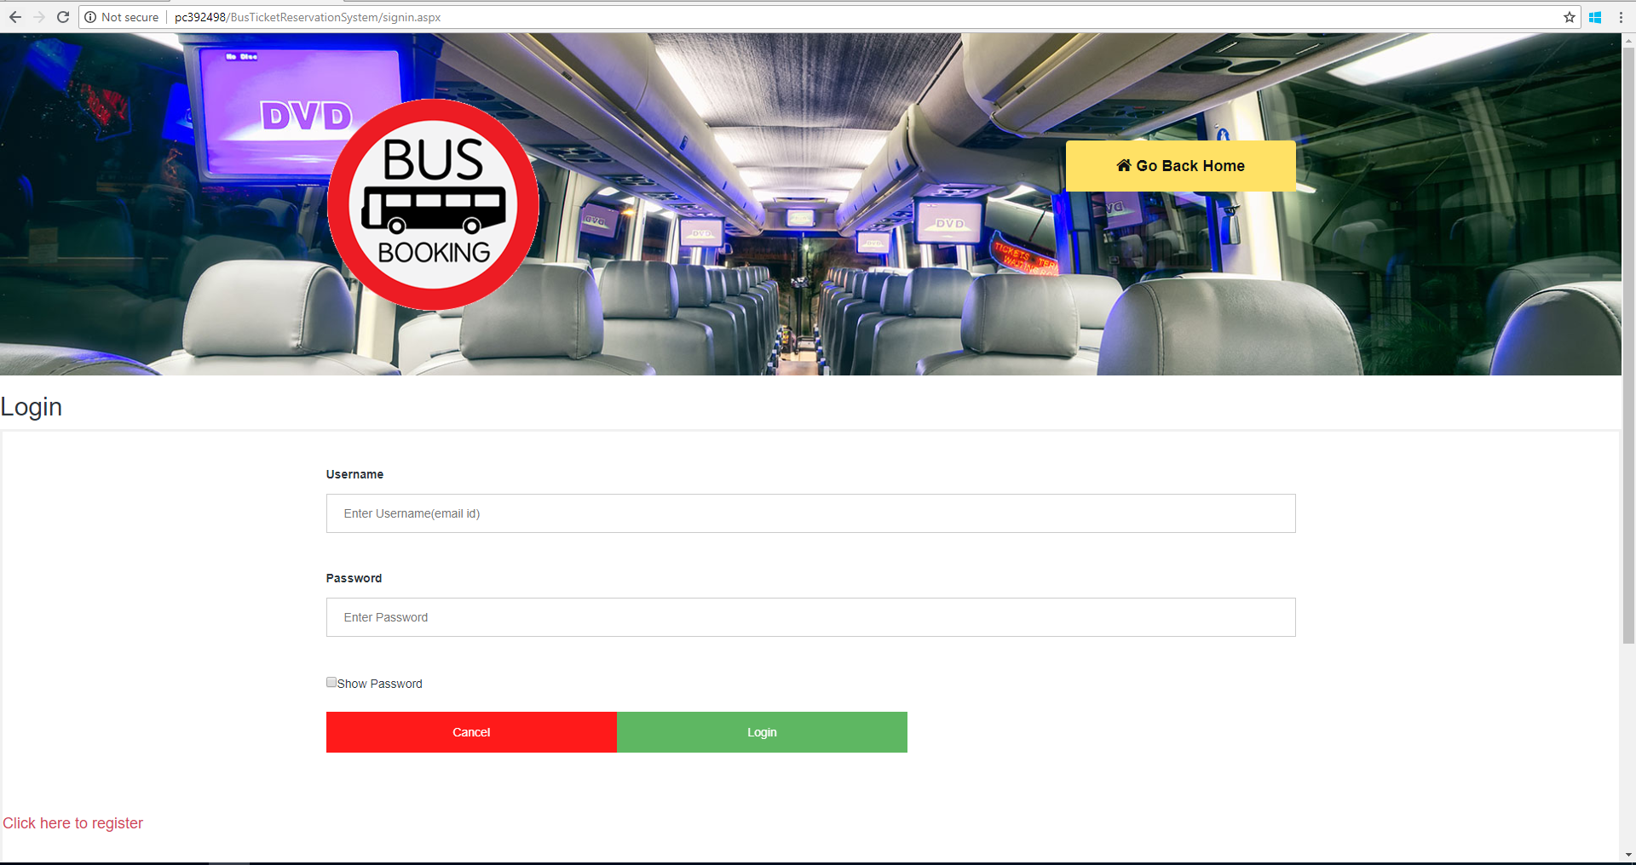

**Search-Page:**

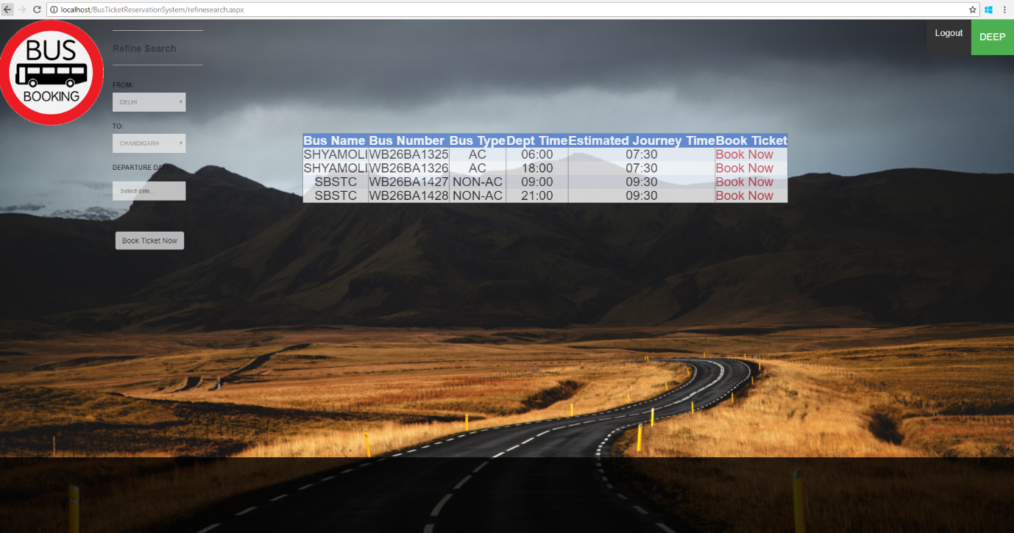

**Seat Selection Page:**

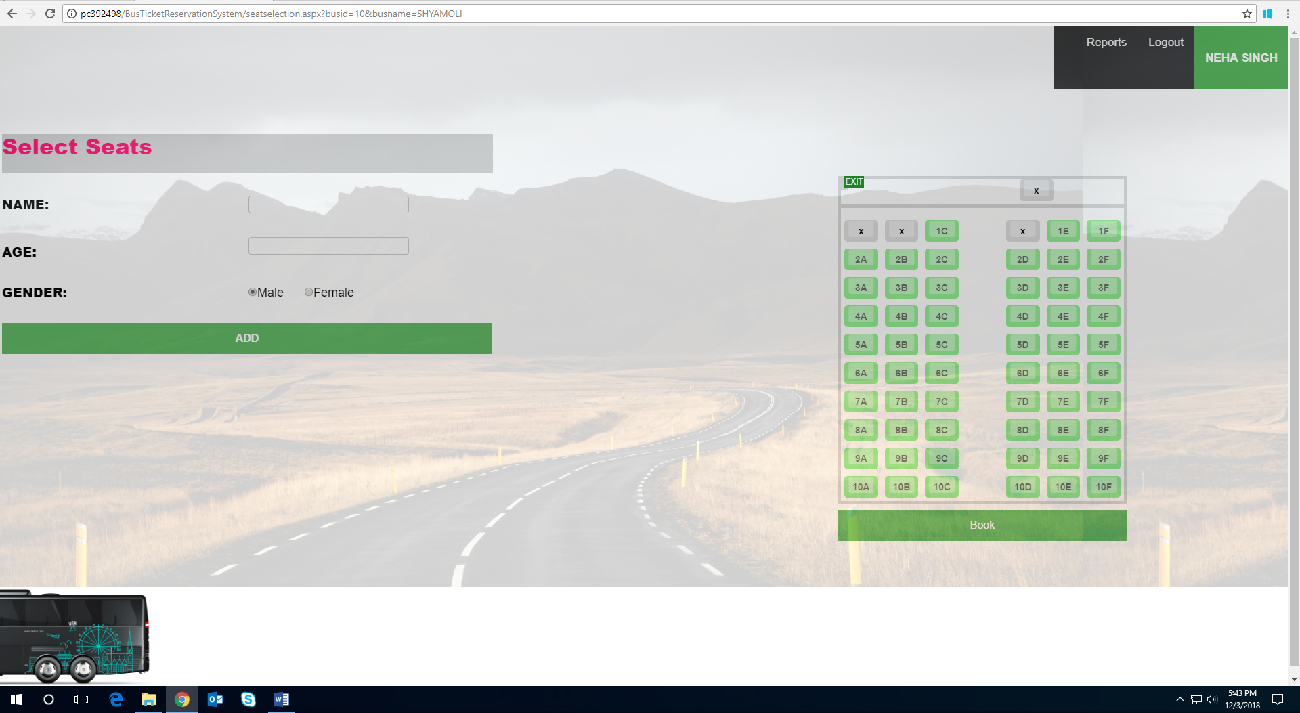

**Booking Confirmation Page:**

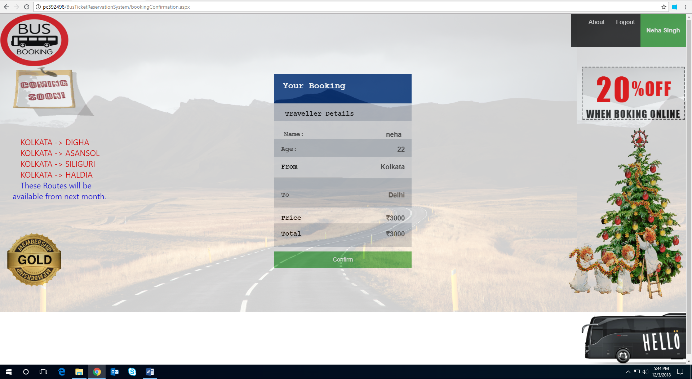

**Payment-Page:**

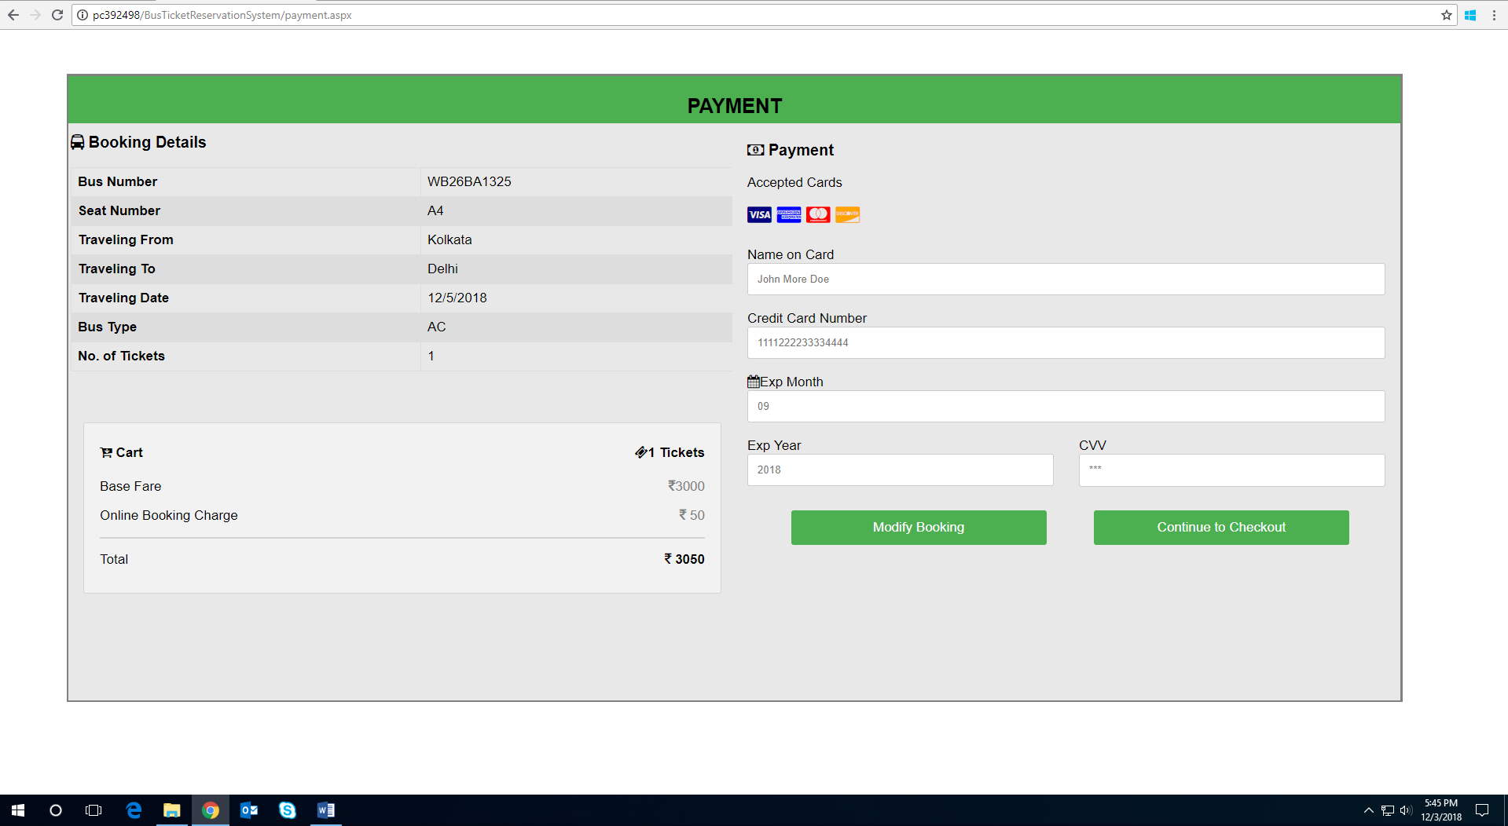

**Cancellation-Page:**

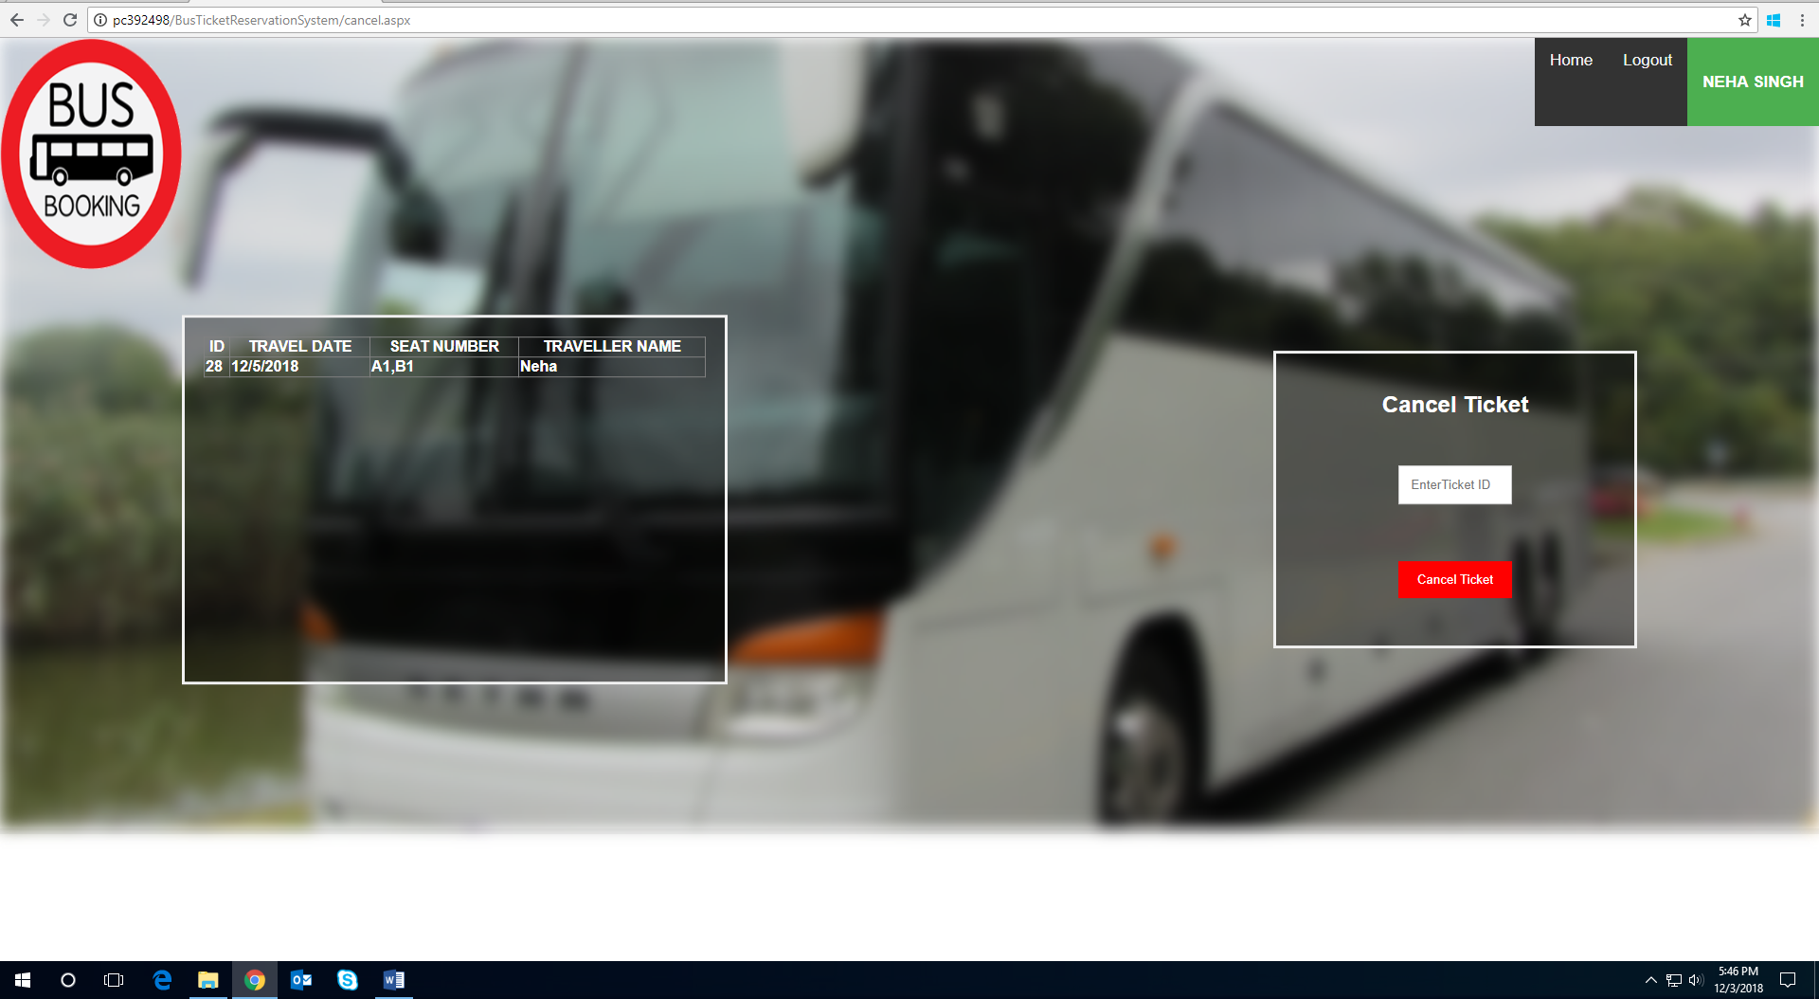

**Admin Page:**

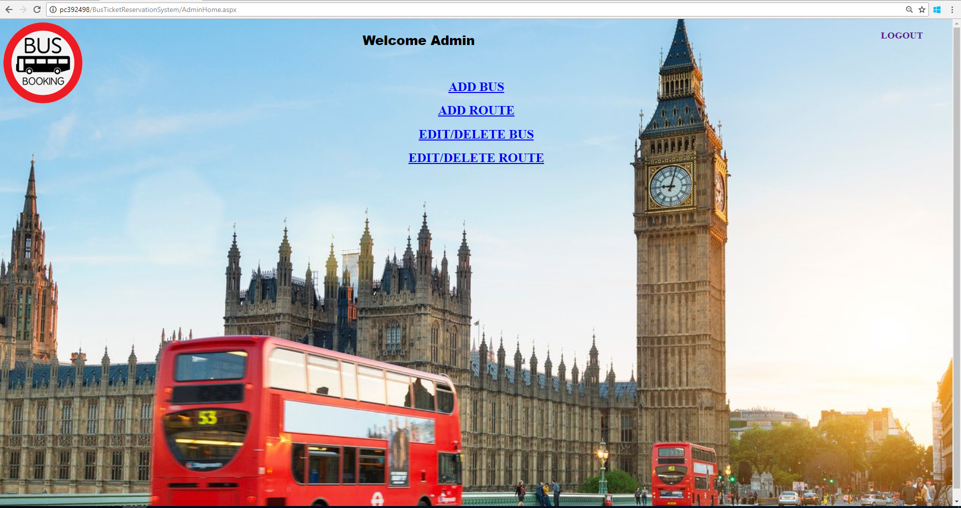

**Add Bus Page:**

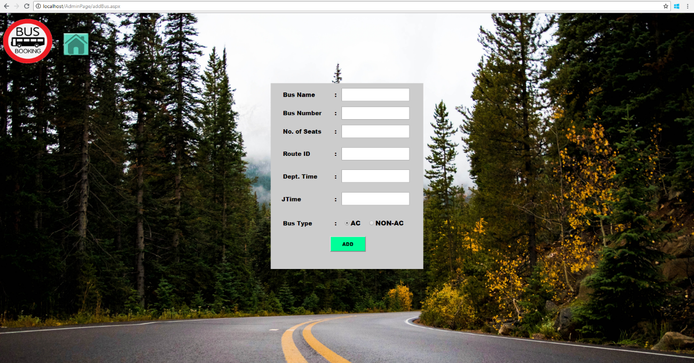

**Add Route Page:**

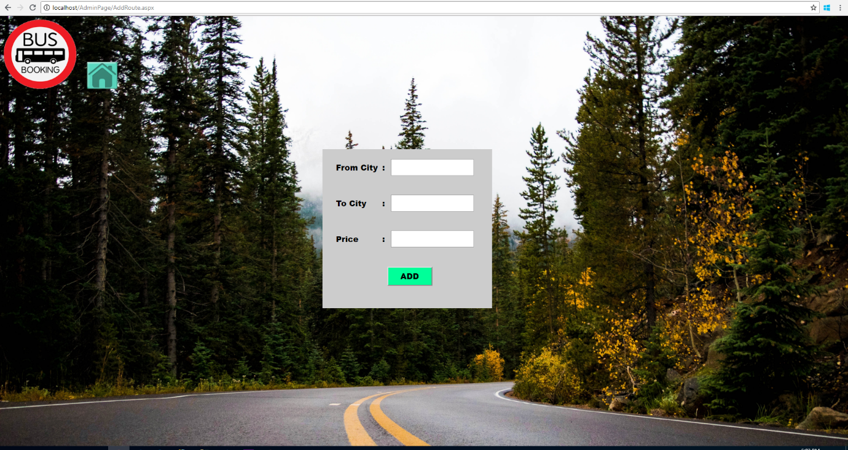

**Edit/Delete Bus Page:**

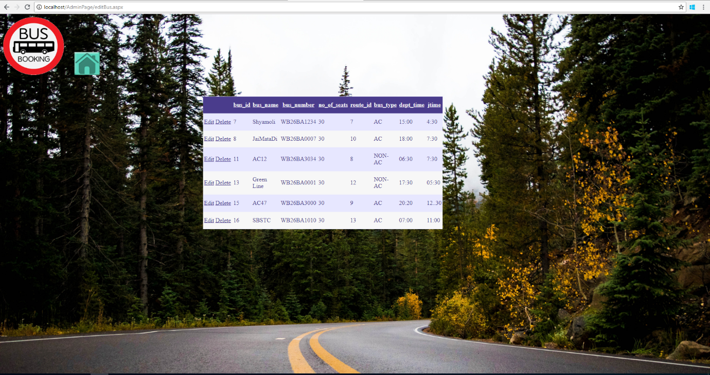

**Edit/Delete Bus Page:**

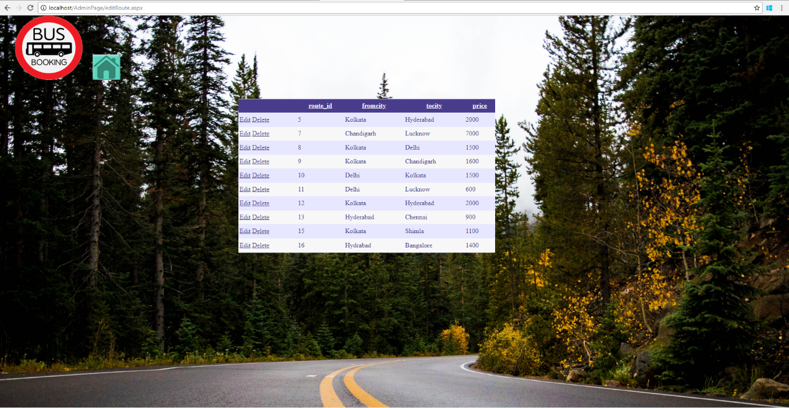

**Reports-Page:**

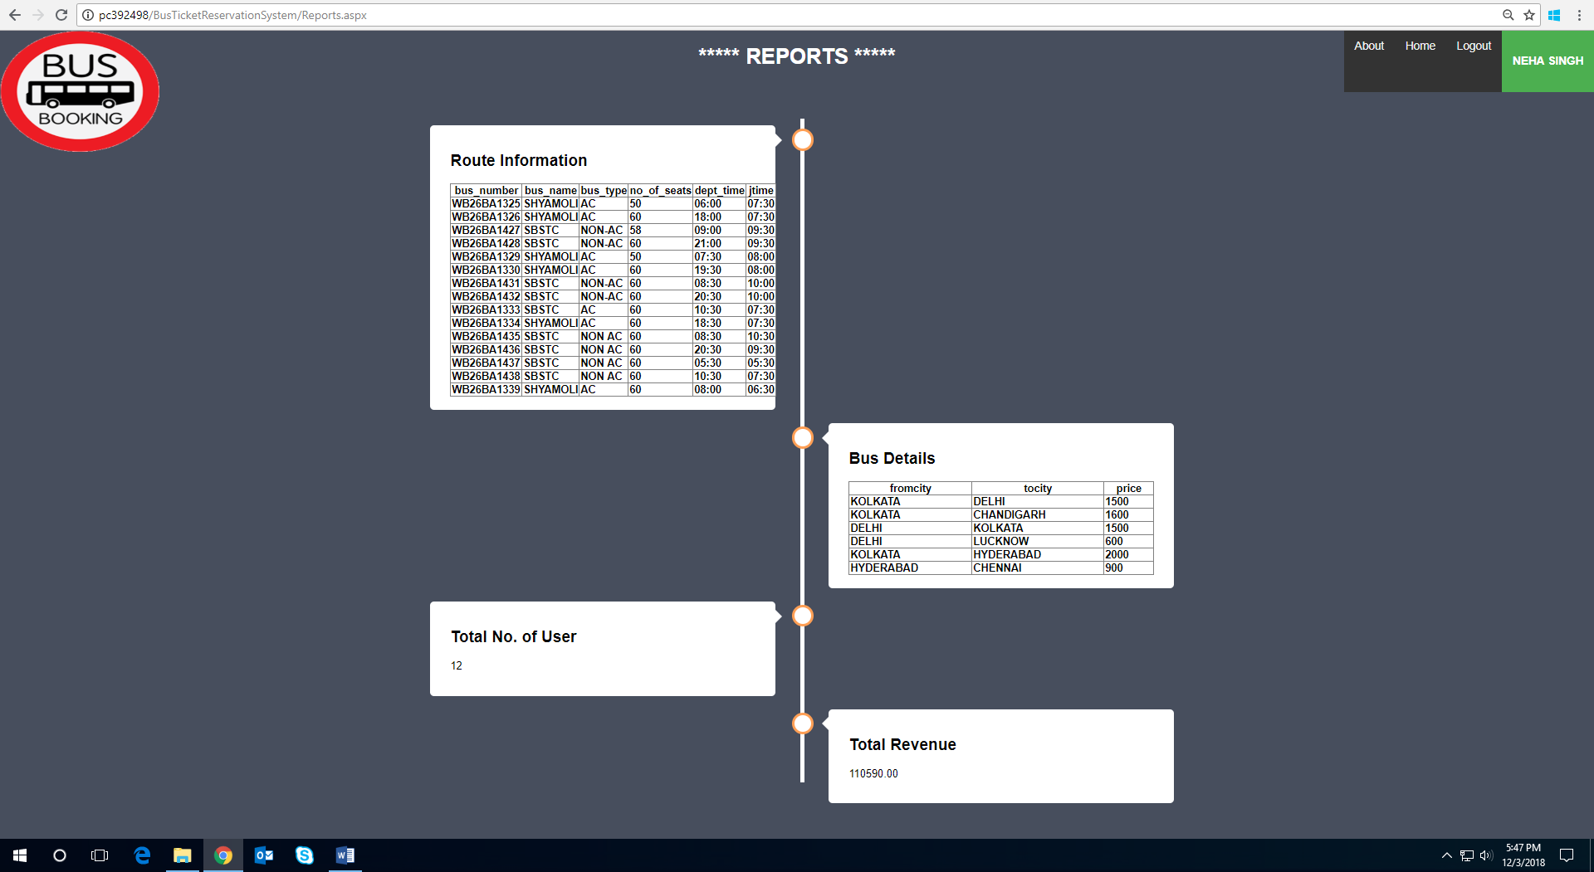

**About Us Page:**

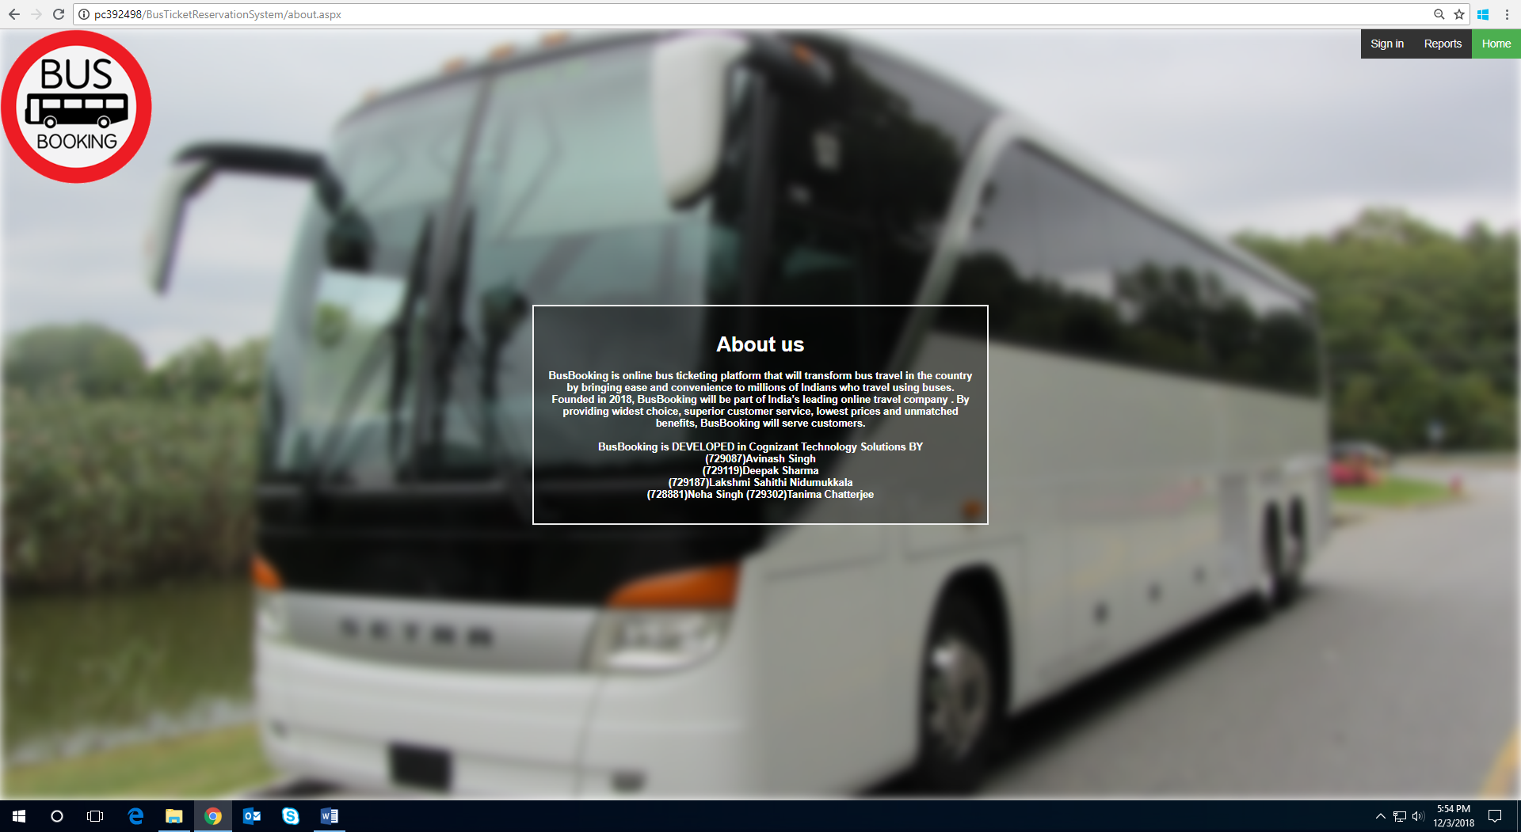

# **References**

<http://online.sbstcbooking.co.in/default.aspx>